**Hospital-Management-System**

**Prepared by:**

Teke Radhika

Gidde Sayali

Salunkhe Priyanka

Pujari Arpita



Submitted to

**EduBridge Certification Program in Java Full Stack**

Year-2022-2023

A Project Report On

**“Hospital-Management-System”**

**Prepared by:**

Gidde Sayali

Teke Radhika

Salunkhe Priyanka

Pujari Arpita

**Guided By-**

Miss.Pooja Mehta Mam

**Introduction:**

* The Hospital Management System (HMS) is designed for any Hospital to replace their existing manual, paper based system.
* This System targets to provide complete solution for Hospital and Health care service.
* Hospital Management System is a project which aims in developing computerized system to maintain all the information of hospital entities.
* It has a facility of admin login through which the admin can monitor the hole system
* Admin modules are managing patient, manage doctor and manage appointments.
* Patients modules are fine doctors and applied for appointments, view appointment and view prescription.
* Doctor modules are view our appointments, write prescription and view patient details.
* Overall this project of ours is being developed to help the hospital administration maintain the hospital management in the best way possible and also reduce the human efforts.

**Objectives:**

* The main objective of this project to manage the records of patients ,doctors and appointments.
* Our objective is using this website patient can search and view doctor profile and also applied for appointment.
* This website project is also become useful for doctors for viewing patient details and write prescription to patients.

**Needs of the System:**

* This is always a need of a system that will be perform online searching of doctor and apply for appointment.
* This system will reduce the manual operation required to maintain all the records and also generate the various report for analysis.

**Purpose:**

* To manage the hospital administrative work. It helps to patients to find doctor details and take appointment online for anywhere.
* This project also help doctor work such as keep information of patient and appointment booking and helps in giving prescription to patient

**What’s in it :**

Our web ApplicationHospital Management System (HMS) is full based on Angular .

**What is Angular:**

Angular is one of the most popular JavaScript frameworks developed and maintained by Google. It is an open-source front-end web framework based on Typescript. It is most suited for developing enterprise web applications because its code is reusable and maintainable.

**Main Page (Home Page):**

• Dashboard: In this section admin can see all detail in brief like total number of patients, total number of appointments ,total number of doctors etc.

• Appointment: In this section admin can view the detail of appointments & have a right to reject and select appointment.

• Patient: In this section admin can manage patient(Add/update).

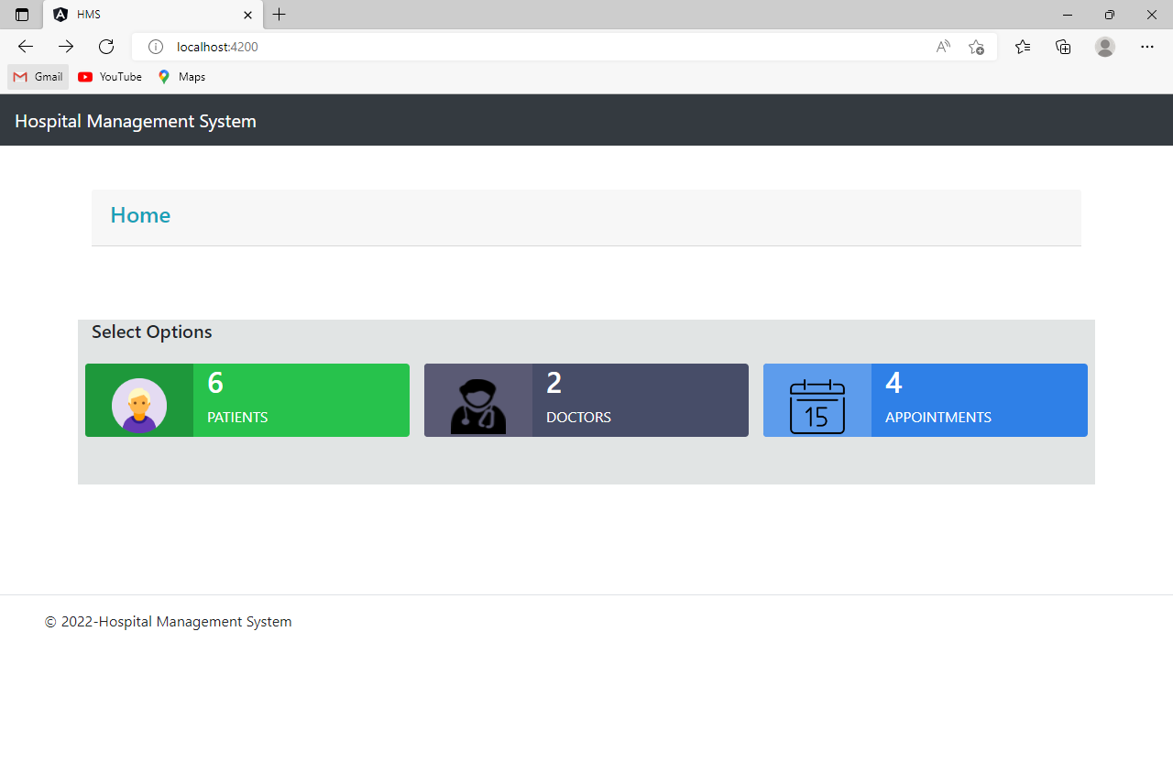

**Inside the main page 3 Options are there for navigation:**

* + - Patient
    - Doctor
    - Appointment
      1. **Patient Option:**
* Appointment: Patient can take appointment with doctor on particular date and time.
* Search: Patient can search doctor name via , specialty and location.
* View Prescription: Patient can we the prescription given by doctor.

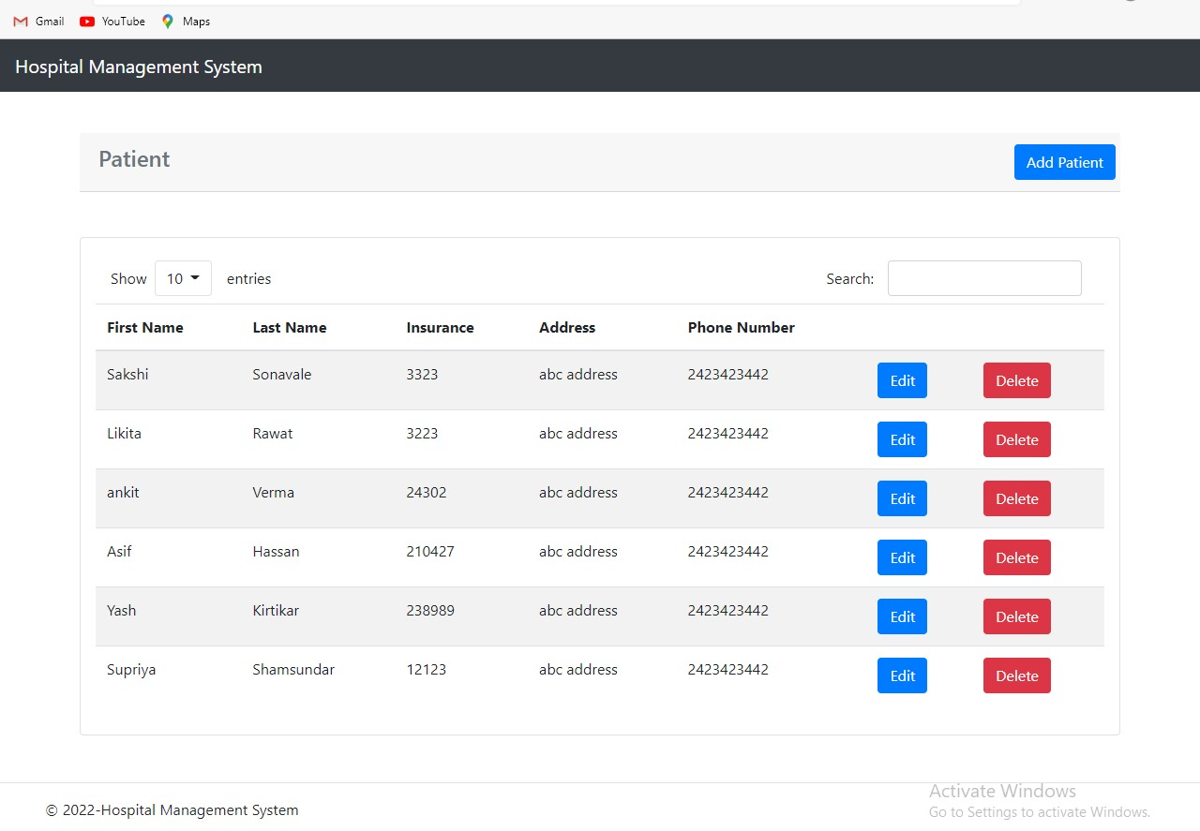

Inside the Patient Option the given table are there in this table shows the sum crude operations.

We can add the number of patients are there. also search the patient .

**2. Doctor Option:**

* Appointment: Doctor can we our appointment details.
* Prescription: Doctor can write prescription to patient.
* View Patient: Doctor can view the patient detail.

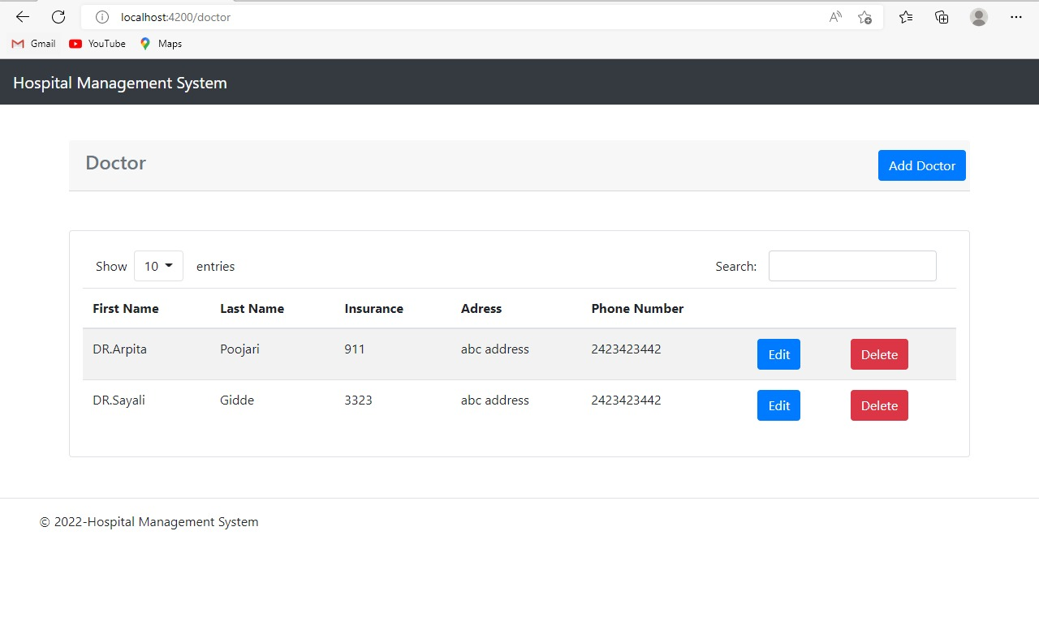

Inside the Doctor Option the given table are there in this table shows the sum crude operations.

We can add the Doctors in their list and also search the Doctors.

**3. Appointment Option:**

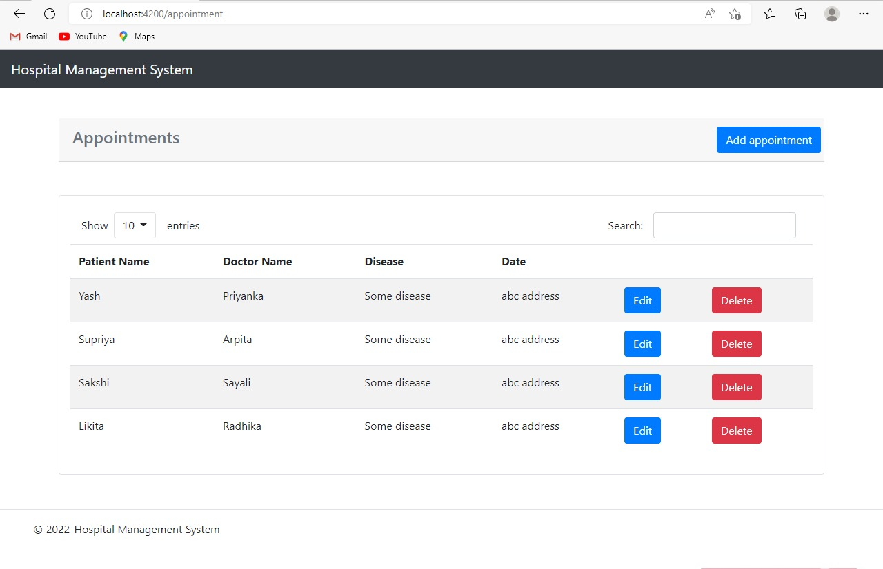

Inside the Appointment Option the given table are there in this table shows the sum crude operations.

We can tack the Appointments shows in the given list and also search the Appointments.

Conclusion:

Implementation of hospital management system project helps to store all the kinds of records, provide coordination and user communication, implement policies, improve day-to-day operations, arrange the supply chain, manage financial and human resources, and market hospital services.

The project entitled “hospital management system is developed using Angular, HTML, CSS and Bootstrap as frontend.

**Thank You.**